Creating a Company Page on LinkedIn

1. Move your cursor over Interests at the top of your homepage and select Companies.
2. Click Create in the Create a Company Page box on the right.

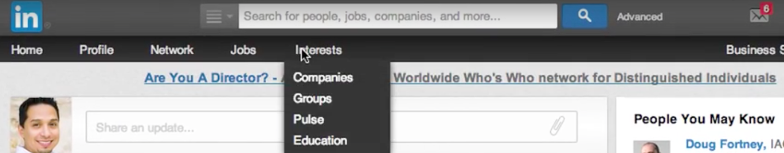

1. Enter your company's official name and your work email address. The email inputted must have @companyname.com/org/net. Example : [brad@boeing.com](mailto:brad@boeing.com) or admin@thetestco.com.

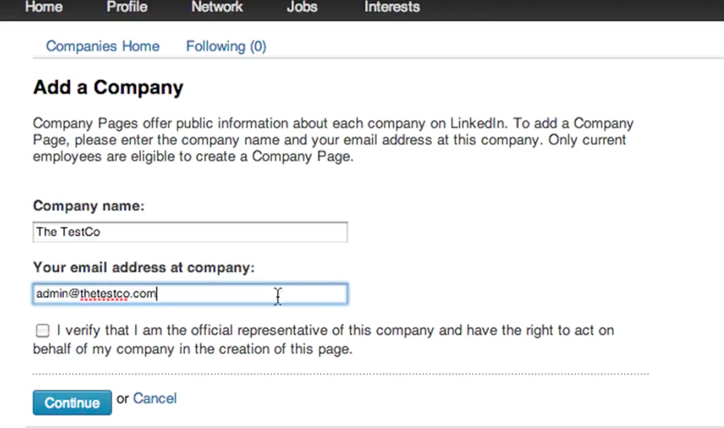

1. Type the name of the designated Admins for your page.
2. Click Continue and enter your company information

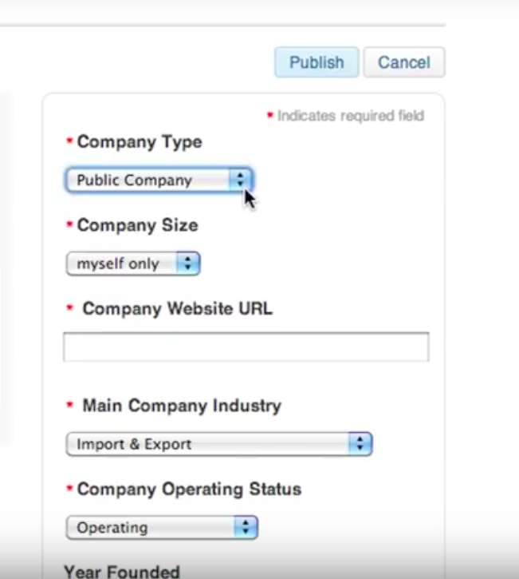

1. 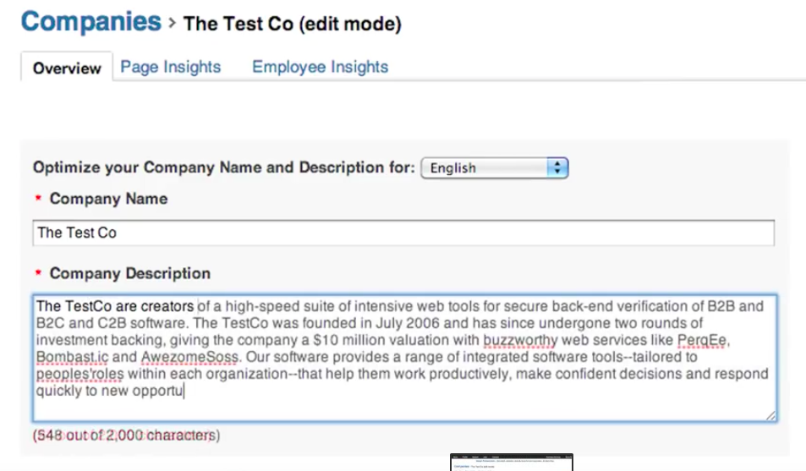To publish your Company Page you must include a company description (250-2000 characters including spaces), and company website URL.

Something that could be added here: “*The Autonomous Flight Systems Laboratory is a research laboratory under the Department of Aeronautics and Astronautics at the University of Washington. Our mission here is to support advances in guidance, navigation, and control (GN&C) technology relevant to autonomous vehicles and their payload. A parallel objective is to integrate this technology into the flight mechanics and controls courses in the Department of Aeronautics and Astronautics to provide students with experience and realistic GN&C systems. Our long list of projects can be characterized into three categories: Strategic Level Projects, Tactical Level Projects, Dynamics and Controls Projects. Some of our very successful and in progress projects including developing a Transponder Based Position Information System, Co-ordinated Searching and Target Identification Using teams of Autonomous Agents among many other successful ones over the years. Under the valuable guidance of our professor, Dr.Christopher Lum, we continue to contribute to the engineering society via cutting edge research and an unwavering confidence in solving problems and advancing the capabilities of autonomous flight systems.”*

1. 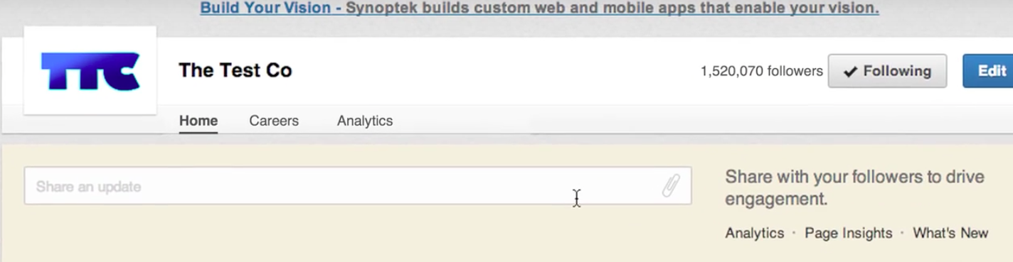To write a post, click on share an update

Sample post :

1. Check out our Exodia rise to amazing heights as it is thrown into the air. This clip is a short snippet from our visit to Australia under the Study Abroad Program. Our objective was to collect essential ground data for our research on enhancing agricultural efficiency using unmanned aircrafts - https://www.youtube.com/watch?v=HEyEN3GNAVQ
2. Check out our recent publication in “…..”here – ( add publication paper/ link to paper)